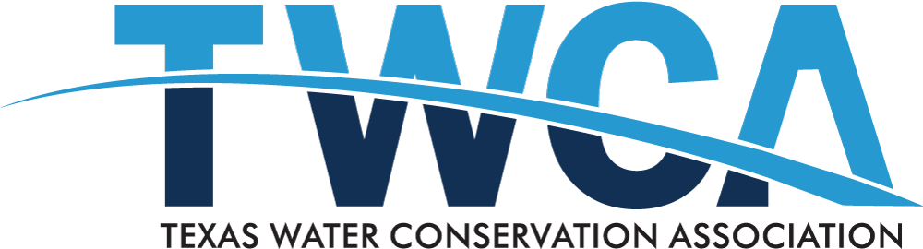
Texas Water Conservation Association
Initiated Efforts of the 86th Legislative Session

The TWCA Flood Response Committee reached consensus on an informational paper about flooding in Texas that was approved by the TWCA Board of Directors, available here. The committee also supports TWDB's Flood Technical Package exceptional items request of its LAR. The TWCA Flood Response Subcommittee has developed a document outlining its principles on flood-related legislation, available here. These principles are consistent with the flood package (SB 7 and 8, HJR 4, and HB 26) that passed this session.

The TWCA Groundwater Committee reached consensus on six proposals that have been approved by the TWCA Board of Directors:
- Brackish Groundwater: The committee proposed an amended version of HB 2377 (Larson, 85th Legislature). This bill passed as HB 722 (Larson/Perry).
- Export: The committee proposed an amended version of HB 2378 (Larson/Perry, 85th Legislature). This bill passed as HB 1066 (Ashby/Perry).
- Abandoned Wells: The committee proposed an amended version of HB 3025 (Tracy O. King, 85th Legislature).
- Water Conservation: The committee proposed new legislation on groundwater conservation districts funding water conservation education.
- SB 1392: The committee proposed an amended version of SB 1392 (Perry, 85th Legislature).
- Groundwater Funding Package: The committee supports TWDB's Groundwater Funding Package exceptional items request of its LAR for funding for groundwater availability modeling and the Brackish Resources Aquifer Characterization System. These efforts were funded.
The TWCA Surface Water Committee continued to support funding for updating Water Availability Models at TCEQ. This effort was funded and passed as HB 723 (Larson/Perry).

